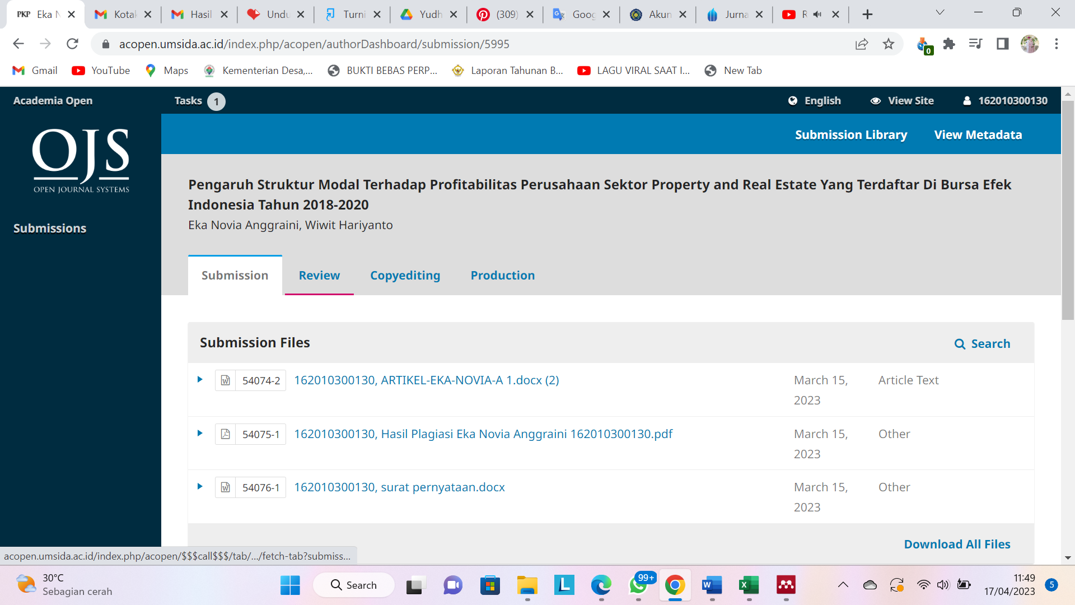

Link = <https://acopen.umsida.ac.id/index.php/acopen/authorDashboard/submission/5995>

Username = 162010300130

Pass = ekanovi

Penerbit = Universitas Muhammadiyah Sidoarjo