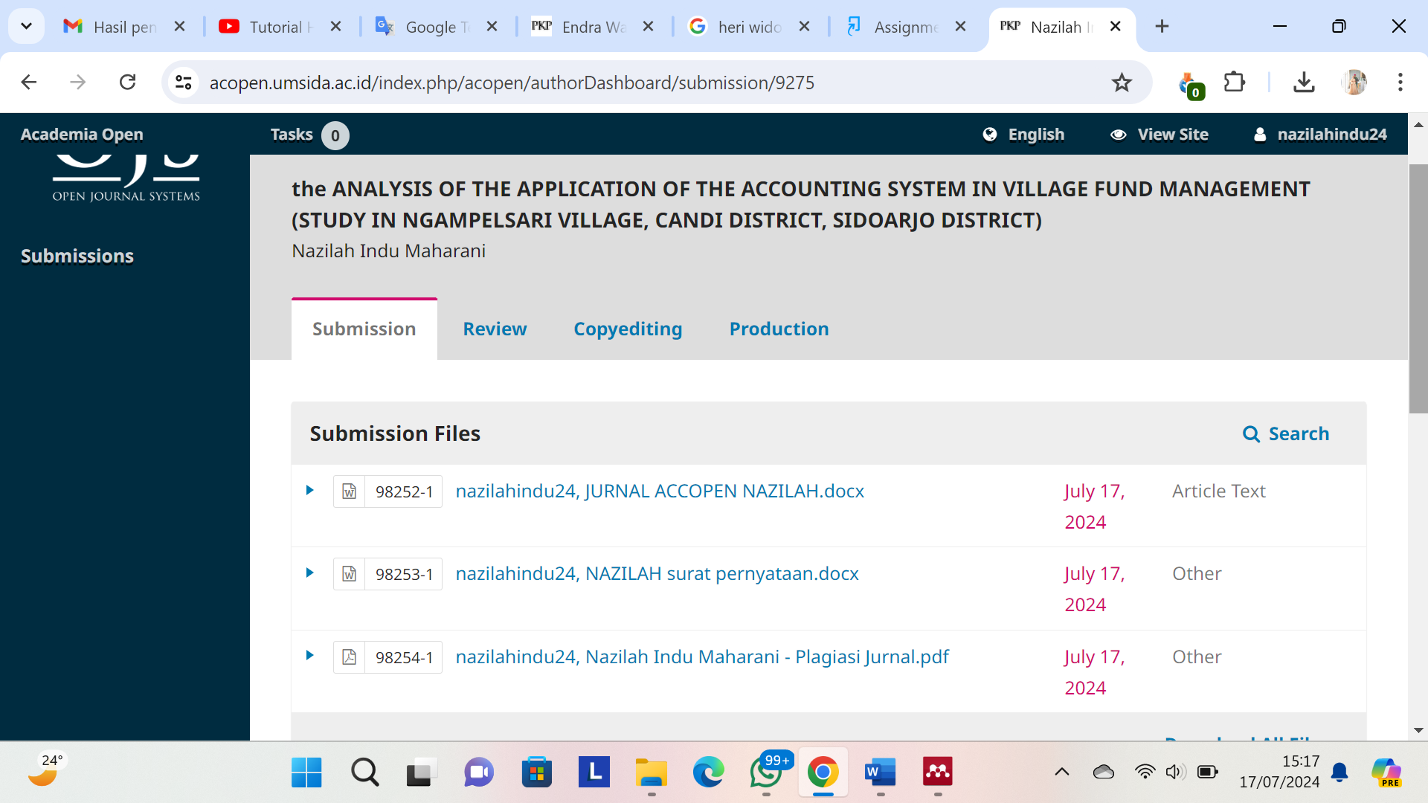

Username : Nazilahindu24

Password:NazilahIndu24

Link : <https://acopen.umsida.ac.id/index.php/acopen/authorDashboard/submission/9275>