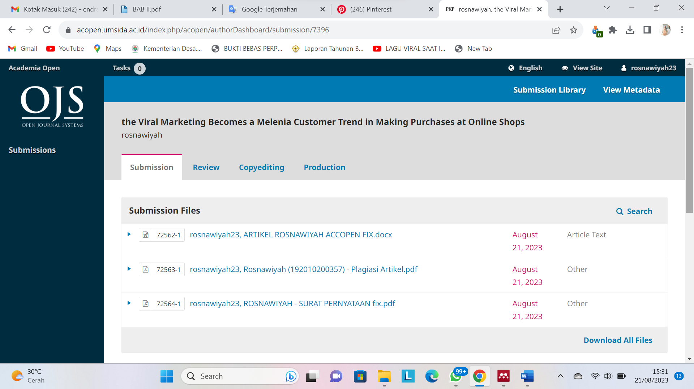

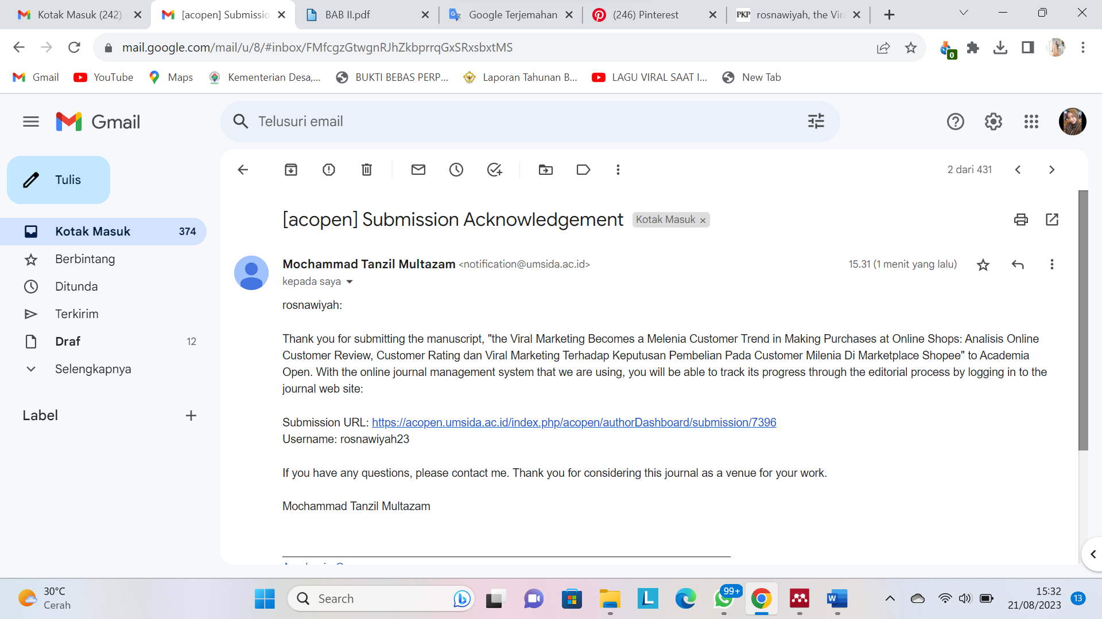

Username : rosnawiyah23

Pass : 23Rosnawiyah

Link : <https://acopen.umsida.ac.id/index.php/acopen/authorDashboard/submission/7396>