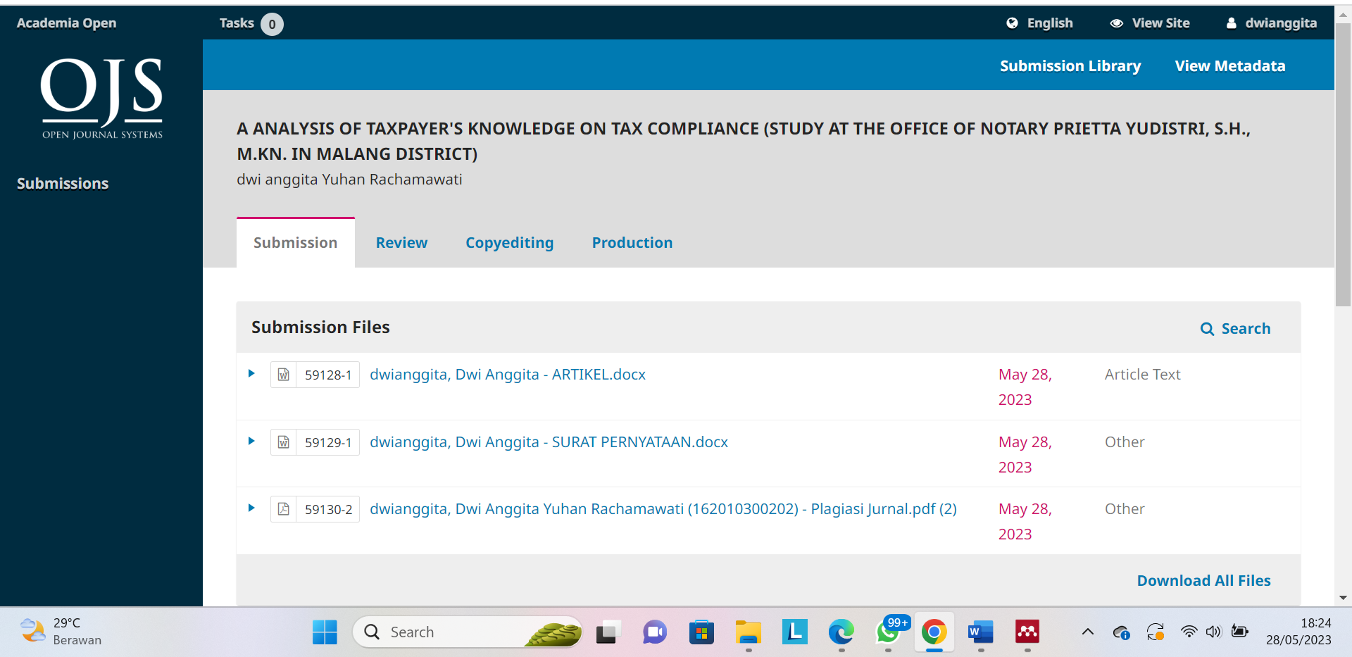

Link = https://acopen.umsida.ac.id/index.php/acopen/authorDashboard/submission/6440
Username = dwianggita
Pass = Dwianggita2023
Penerbit = Universitas Muhammadiyah Sidoarjo

